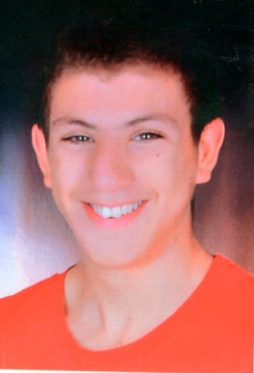­



2018

**OBJECTIVE**

Dynamic, smiling and very motivated.

I am looking for new professional opportunities in the world of carpentry.

**HIJEB IBRAHIM**

**LANGUAGES**

**HOBBIES**

**EDUCATION**

**Certificate of Professional Competence in Furniture Joinery**

**Sectoral Center for Trades Training**- Sousse -Tunisia

* Arabic: native speaker
* French: Good
* English:Good
* Communication
* HR Policies
* Management
* Leadership

**SKILLS**

**WORK EXPERIENCE**

**Carpentry within the company “Ma Belle Cuisine”**

2018-2020 Sousse Tunisia

* Assembly of kitchen furniture and layout

**Carpentry within the company “Ma Belle Cuisine”**

2020-2022 Sousse -Tunisia

* Carpentry and Interior Furnishings.

**Menuiserie**

Rue Yakout Elhamaoui Cité Erriadh Sousse 4023

+216 22 064 800

+216 29 261 413

* Travel
* Swimming

ibrahimhajeb08@gmail.com

©AZURIUS – Modeles-de-cv,com